

**National University**



of Computer

and

Emerging Sciences

Chiniot

-

Faisalabad Campus



**EE1005 – Digital Logic Design**

**Quiz# 2**

**Instructor:** Muhammad Adeel Tahir

**Sections:** BCS-2F

**Before you come with query, please check:**

* **Did I read the instructions carefully?**
* **Did my question fulfil the requirements as given in each question?**
* **Is my question specific (not too broad)?**

**Solution Key Quiz #2:**

**Question 1: Solve the following parts of the questions carefully.                         [12 marks]**

1. Convert the sequence from to Gray code. Show proper working or no marks will be given **(2+2=4)**

**Marking Criteria:**

**(1 mark):** **Conversion of first decimal number (60) to correct Gray code (100010)**

Includes at least one intermediate step (showing binary conversion or XOR).

**(1 mark):** **Conversion of second decimal number (61) to correct Gray code (100011)**

Includes at least one intermediate step (showing binary conversion or XOR).

**(2 marks):** **Demonstrated understanding of conversion process**

Clear explanation of steps taken (binary conversion, right-shift, XOR).

**Solution:**

**Conversion Steps**

1. **Convert to binary:** Convert each decimal number to its standard binary representation.

o 60 (decimal) = 111100 (binary)

o 61 (decimal) = 111101 (binary)

2. **XOR with right-shifted version:**

o Right-shift each binary number by one position (dropping the rightmost bit).

o Perform an XOR operation between the original binary number and its right-shifted version.

**Calculations:**

* **60:**
  + 111100 (original)
  + 011110 (right-shifted)
  + **100010 (Gray code)**
* **61:**
  + 111101 (original)
  + 011110 (right-shifted)
  + **100011 (Gray code)**

**The Gray code representations for the sequence 60, 61, 62, 63 are:**

* 60: 100010
* 61: 100011

1. Convert the following into BCD code and add: 295 + 157                    **(2)**

* **0.25+0.25 marks:** Correct BCD representations of each number
* **1.5 marks:** Correctly solved

Solution

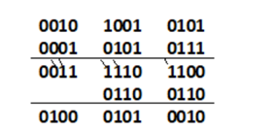

1. In an 8-bit two’s-complement system, what decimal number does the bit pattern **10000111** represent? Show proper steps in finding the actual decimal number. **(2)**

* **(1 mark):** Correct identification of the number as negative (leading bit is 1). **0 if this step is wrong**
* **(1 mark):** Correct calculation of the decimal equivalent

**Solution**:

**1. Check the Sign Bit:**

* If the first bit is '1', the number is negative.
* If the first bit is '0', the number is positive.

**2. If Negative:**

* Flip all the bits (0s become 1s, 1s become 0s).
* Add 1 to the result.
* Put a negative sign in front of the converted decimal number.

**In the given question**:

1. **Sign Bit:** The first bit is '1', meaning negative.
2. **Flip Bits:** 10000111 becomes 01111000
3. **Add 1:** 01111000 + 1 = 01111001
4. **Convert to Decimal:** 01111001 equals 121
5. **Add negative sign:** The result is -121
6. One of the following bit patterns is valid BCD (binary-coded decimal), but the other one is not, Which one is not valid? For credit to be given, you must give a correct reason. **(1)**
7. **100110110100**
8. **100100111000**

* **(0.5 marks):** Correctly identifying the invalid BCD pattern
* **(0.5 marks):** Providing a valid reason
* **(1 marks**): Number identification
* **(0.25 marks) Partial Credit (Optional):** Identifies the wrong pattern as invalid but provides a correct reason based on BCD rules.

**Solution:**

100110110100: If we break this down into groups of four, we get 1001 1011 0100. The second group, "1011", is not a valid BCD representation.

100100111000: If we break this into groups of four, we get 1001 0011 1000. All of these groups represent valid BCD digits.

What number does the valid bit pattern from part (d) represent? Give your answer in base

ten.  **(1)**

**e.** The *ten-bit* Gray code for (**353)10** is **0111010001**. Explain briefly but precisely why it cannot be true that **0111010100** is the ten-bit Gray code for (**354)10** **also** calculate gray code for 35410.

**(2)**

**Explanation (1 mark):**

**(1 mark):** Clearly states the key property of Gray codes: only one bit changes between adjacent values. Demonstrates understanding by pointing out that the provided Gray codes differ in two bit positions.

**Calculation (1 mark):**

**(0.5 marks):** Correctly converts 354 (decimal) to binary.

**(0.5 marks):** Correctly calculates the Gray code from the binary representation of 354.

**Reason:**

* 0111010001 represents 353 in decimal.
* 0111010100 is not a valid Gray code for 354 in decimal because it does not satisfy the property of Gray codes, where adjacent numbers differ by only one bit.

**Gray code for 35410 =** 0111010011

**Question 2: Solve the following problems, show proper working. [15 marks]**

1. Using 10's complement. subtract 72532 - 3250. **(2)**

* **(1 mark):** Correctly finds the 10's complement of 3250.
* **(1 mark):** Correct calculation and final answer (including handling carry/discard).

**Solution:**

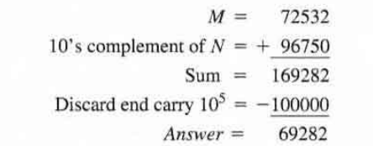

1. Given the two binary numbers **X = 1010100** and **Y = 1000011** perform the subtraction

i)   X - Y and  **(2)**

ii)  Y - X by using 2's complements.**(2)**

**i) X - Y (2)**

**(2 marks):** Correct subtraction (setup, borrowing if needed, and final binary result).

**ii) Y - X using 2's complements. (2)**

**(1 mark):** Correctly finds the 2's complement of X.

**(1 mark):** Correct addition and final result (including handling carry/discard).

**Solution:**

1. Simplify the given Boolean expressions, and specify the laws used for each step within brackets where the question does not specifically mention which laws to be used. **Note**: If the laws used are not mentioned, the question will receive zero marks even if the answer is correct. **(4)**

* **(1 mark):** Correct first step of simplification + identifying the law used.
* **(1 mark):** Correct second step of simplification + identifying the law used.
* **(1 mark):** Correct third step of simplification (if applicable+ identifying the law used).
* **(1 mark):** Correct final simplified expression.
* **0 in case of no laws mentioned.**

**Solution:**

=[AB’C+AB’BD+(AB)’]C **AB’(C+BD) = AB’C + AB’BD (Distributive Law)**  
=[AB’C+A.0.D+(AB)’]C **B’B=0** **(Compliment Law : A.A’ = 0)**  
=[AB’C+(A’+B’)C]  **(AB)’ = A’+B’ (Demorgan’s)**  
=**AB’C** + A’C + **B’C**

=A’C + B’C(A+1) **Distributive Law (AB’C + B’C) = B’C(A+1)**

=A’C + B’C(1) **A+1= A (Additive identity)**

=A’C+B’C  
=C(A’+B’)

=C(AB)’ **A’+B’ = (AB)’ (Demorgan’s)**

1. Apply Demorgan’s theorem to the following expressions: **(1+1+1=3)**

**Binary checking**: Full marks if correctly solved else zero.

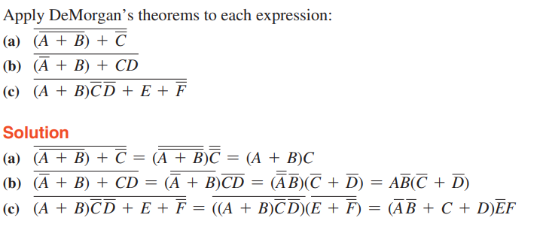

1. Taking the Boolean expression of **Exclusive OR Gate as starting point**. Use any rules or laws that are applicable to **develop an expression for the exclusive-NOR gate**. **(2)**

* **(1 mark):** States the Boolean expression for Exclusive-OR (A ⊕ B).
* **(1 mark):** Correctly derives the Exclusive-NOR expression through negation of the Exclusive-OR expression:

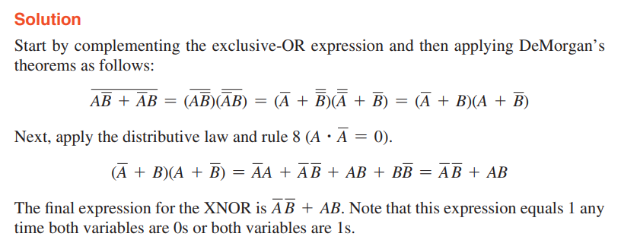

**Q3: Given the following circuit below, Solve the given parts carefully. [10]**

1. Derive the Boolean expression from the following circuit diagram. Make sure you label each output carefully in neat and clean handwriting (**on the diagram)** to score the maximum marks. Write your final answer in the space provided. **(5)**
2. Draw the truth table of the derived equation. **(5)**

* **(1 mark):** Correct labeling of intermediate outputs on the diagram (letters or brief expressions).
* **(1 mark):** Correct expression for the output of the first logic gate, based on labels.
* **(1 mark):** Correct expression for the output of the second logic gate, based on labels.
* **(1 mark):** Correct expression for the output of the final logic gate, based on labels.
* **(1 mark):** Correct overall Boolean expression in the provided space.
* **(0 or 5) Binary for truth table:** 2 mistakes in value leads to 0 else complete marks

**Q:4 Determine the output time diagram (waveform) for the XOR gate and for the XNOR gate, given the input waveforms, A and B, in Figure given below. (5)**

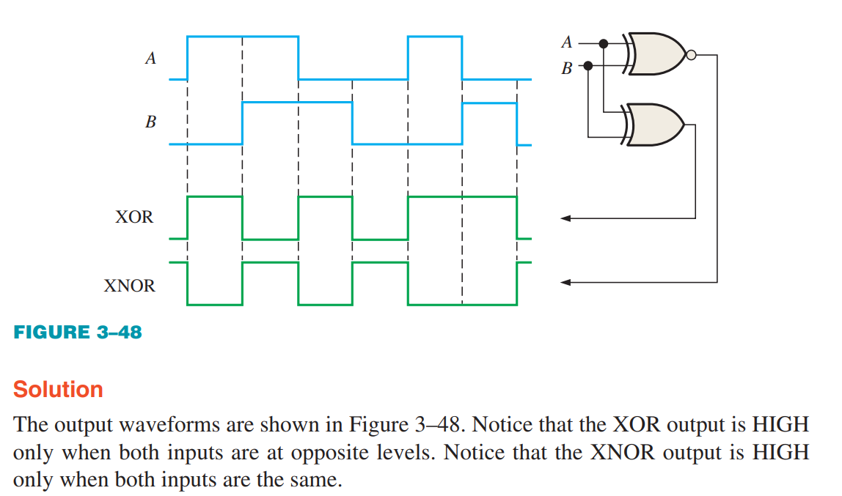

**Binary checking:** Single mistake leads to 0 since it was a very simple XNOR and XOR logic.

**Q5: Convert the hexadecimal to base-7. Proper working must be shown. (2.5+2.5=5)**

* **(4.5 mark):** Correct identification of the methods + answers
* **(0.5 marks):** Presentation, clarity, and completeness of working.

**(9A3.F)16**

**Solution:**

Convert base 16 to decimal first.

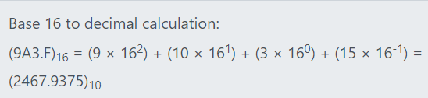

Convert base 10 to base 7 by repeated division for integer part and solve the fractional part separately as taught in lecture.

10123.6363 (Ans)

**Q:6 Choose the correct answer [3 marks]**

**1) Which of the following is a characteristic of Gray Code?**

**a) Only one bit changes at a time**

b) It is a weighted code

c) It is a decimal to binary code

d) All of the above

**Explanation:** The Gray code is a binary numeral system where two successive values differ in only one bit. This is its key characteristic and what differentiates it from other binary codes.

**2) What is the range of 8-bit signed binary numbers?**

**a) -128 to 127**

b) 0 to 255

c) -256 to 255

d) -127 to 128

a) -128 to 127 Explanation: In an 8-bit signed binary number system, the range is from -128 (10000000 in binary) to 127 (01111111 in binary).

**3) Which of the following gates is known as an inverter?**

a) AND gate

b) OR gate

**c) NOT gate**

d) NAND gate

c) NOT gate **Explanation:** A NOT gate, also known as an inverter, is a logic gate that outputs true or ‘1’ if the input is false or ‘0’, and outputs false or ‘0’ if the input is true or ‘1’.